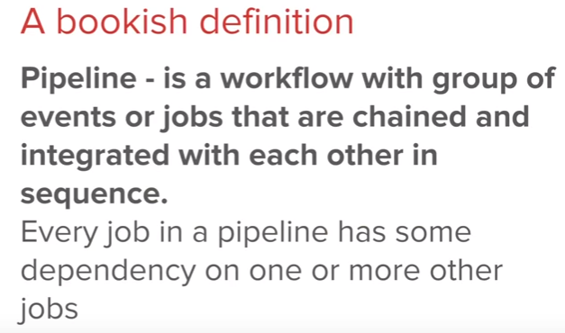

**Pipeline:**

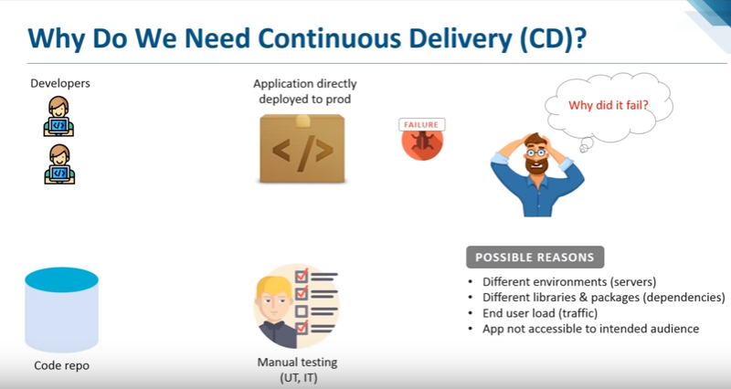

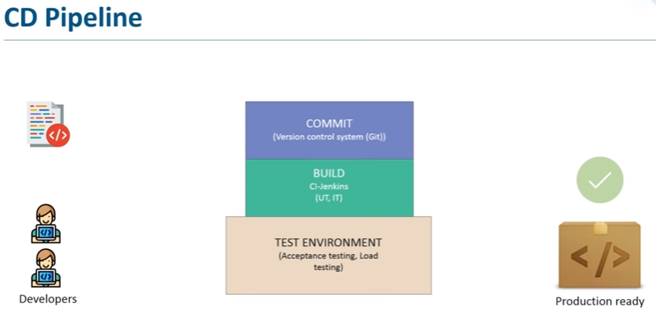

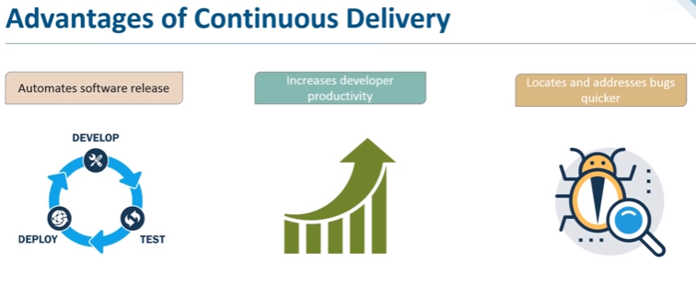

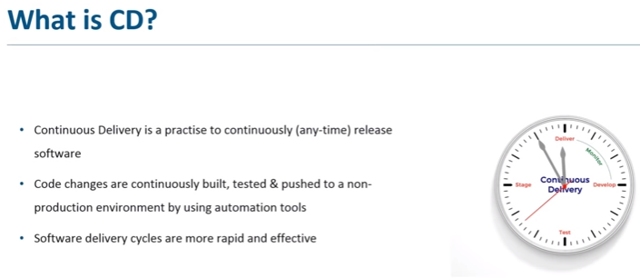

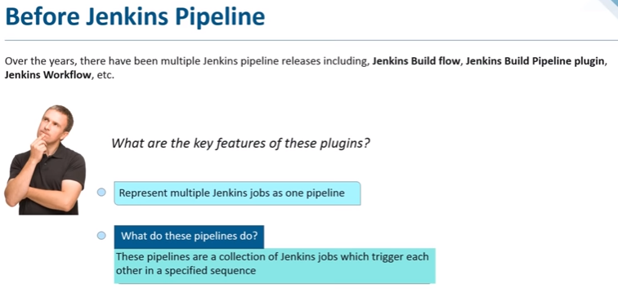

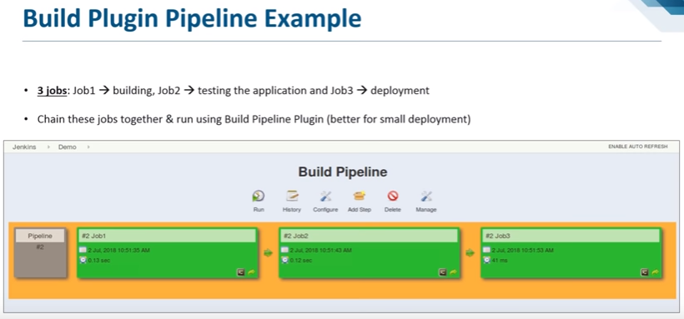

* As above we have created two jobs and combined them together in pipeline

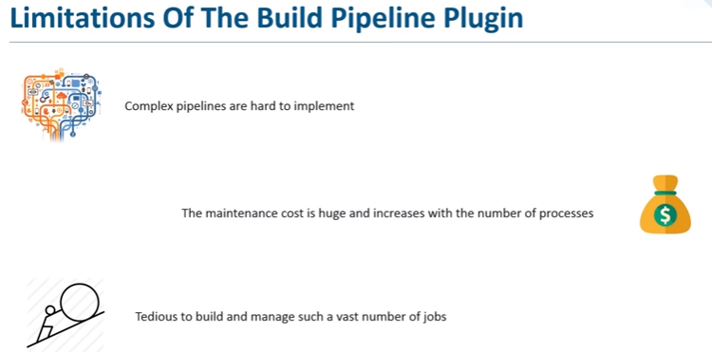

* This was fine with small applications, but for many no.of jobs, it’s not good to create hundreds of jobs and combine them together

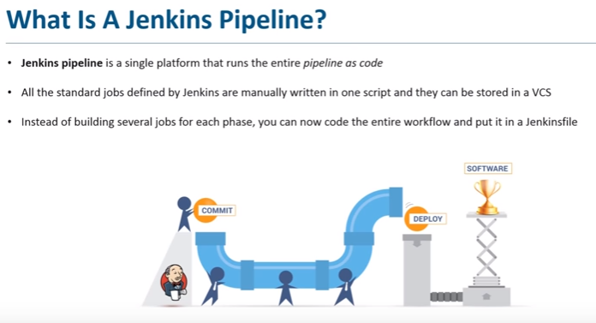

* Now, in Jenkins pipeline, it is a single platform that runs as code
* Instead of creating manually, we can code these jobs and run in pipeline. This code called as Jenkins file in a text format

**Key features of Jenkins pipeline:**

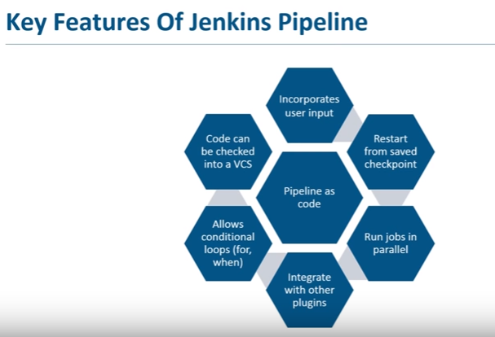

* It runs as code and that can be checked in to VCS. So, developers can easily access and edit that
* Instead of restarting the job, we can save it and comeback to that checkpoint and start again
* It runs the jobs parallelly. We can devide the jobs in groups and run

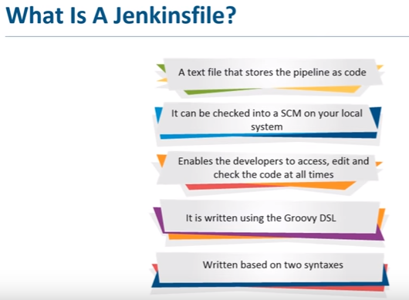

* It written in groovy domain specific language

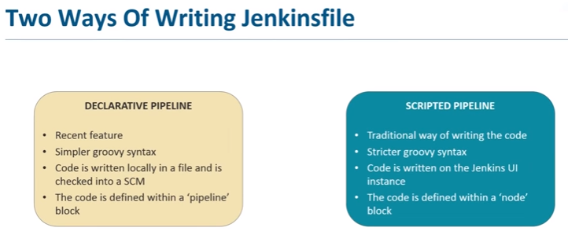

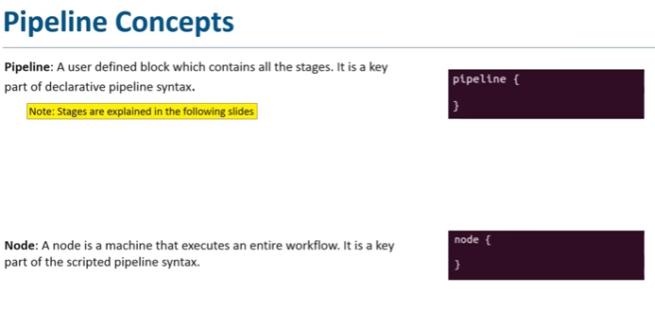

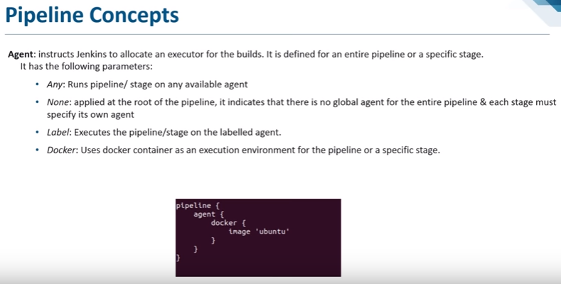

* Agent is an executor where is running the entire pipeline or a specific stage which we have defined
* Agent has a few parameters. Any parameter means it runs on any available agent

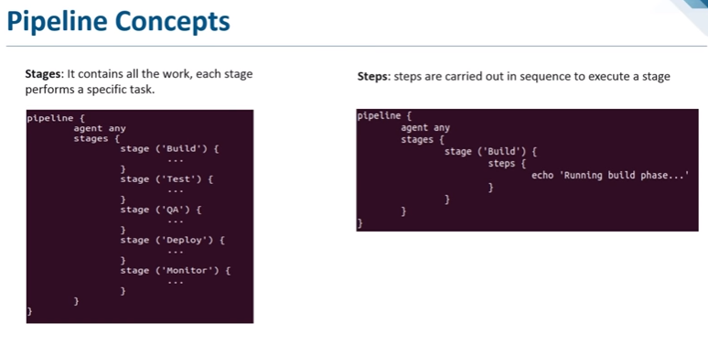

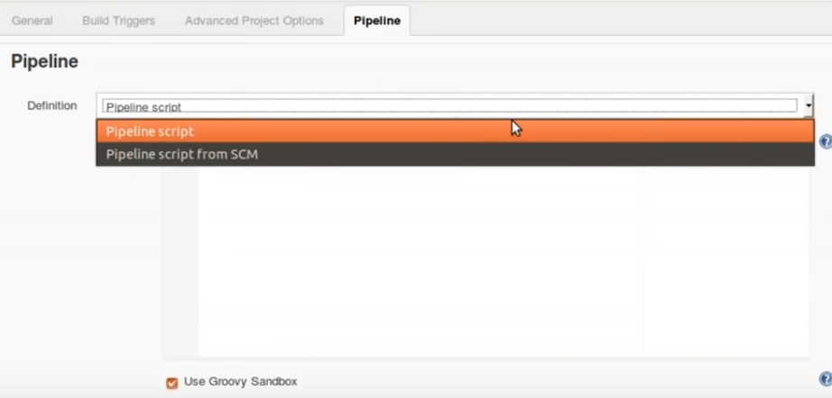

* If we want to write the scripted pipeline, we need select pipeline script and write the code under that
* If we want to use declarative pipeline, select SCM option and under path for script, we need to give the name of jenkinsfile

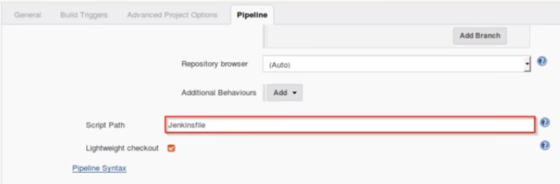

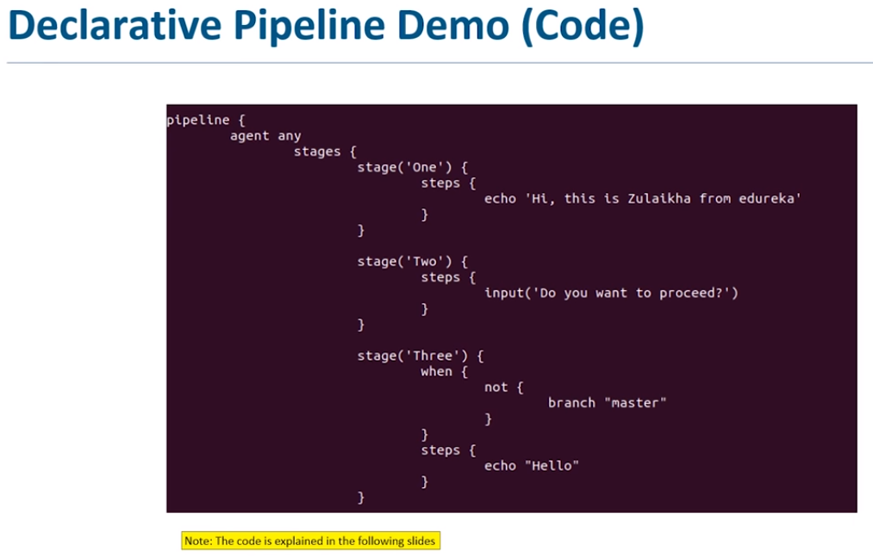

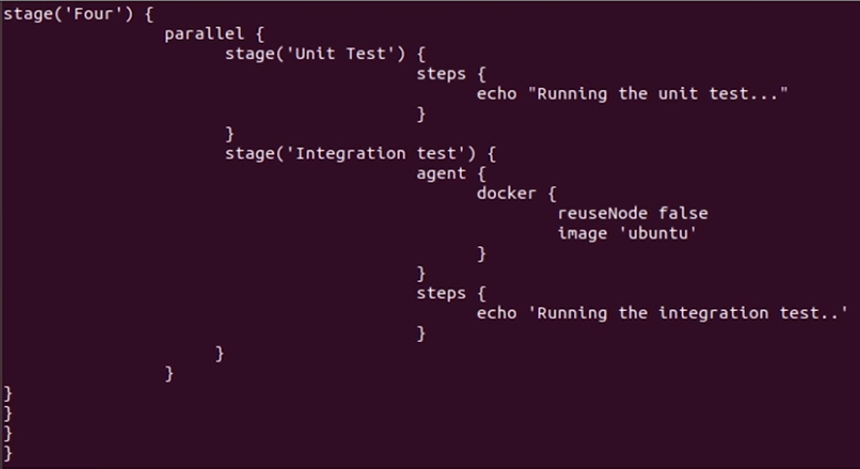

* Stage 4 is configured as parallel

